Ben Sottile

Beer Master

Beer Table

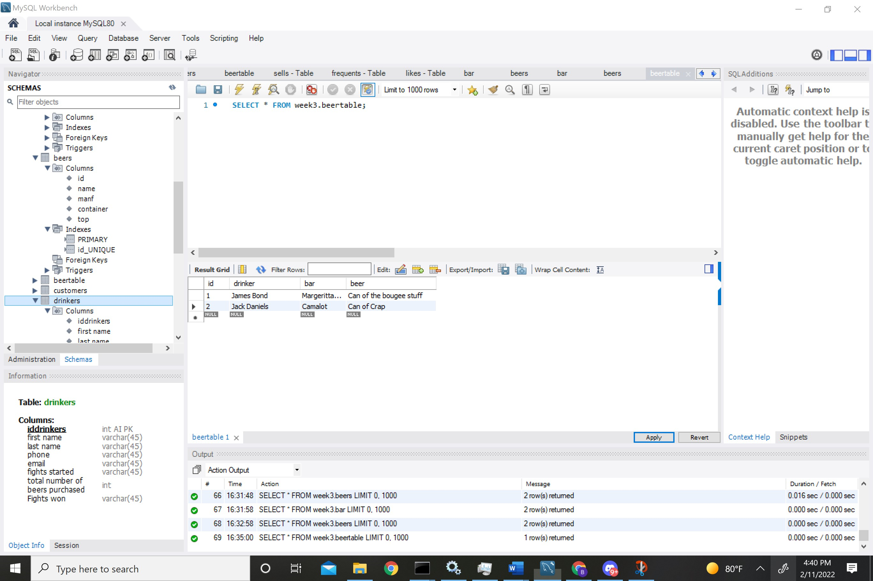

Bar Table

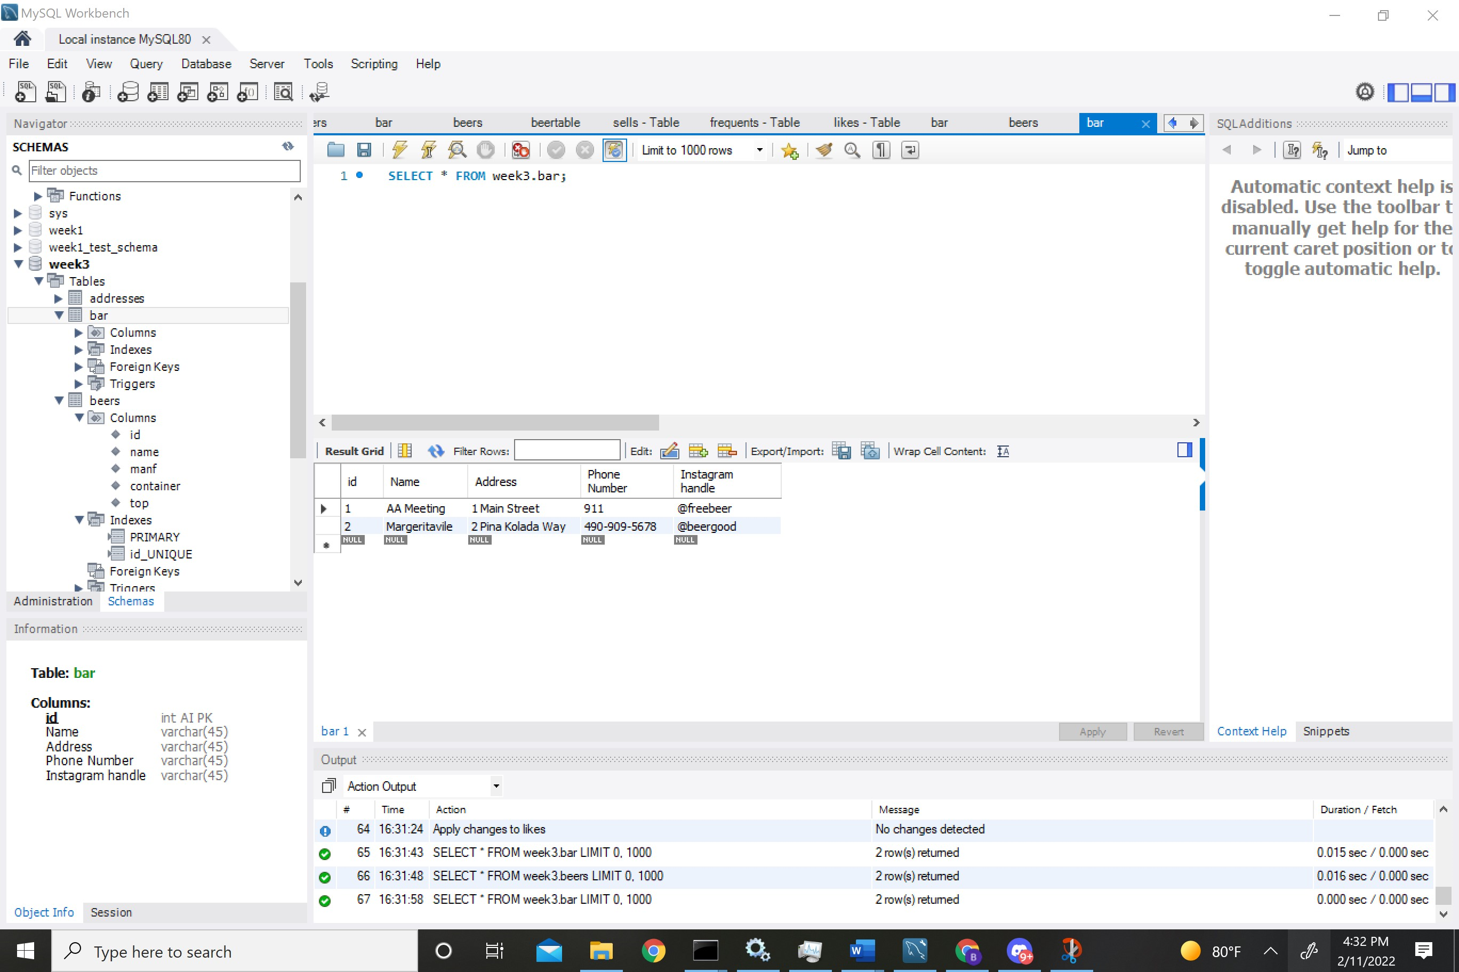

Beers

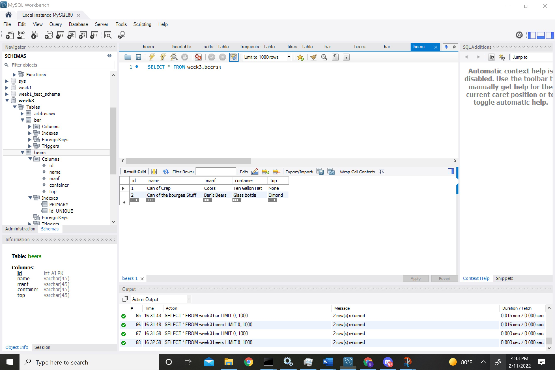

Bars

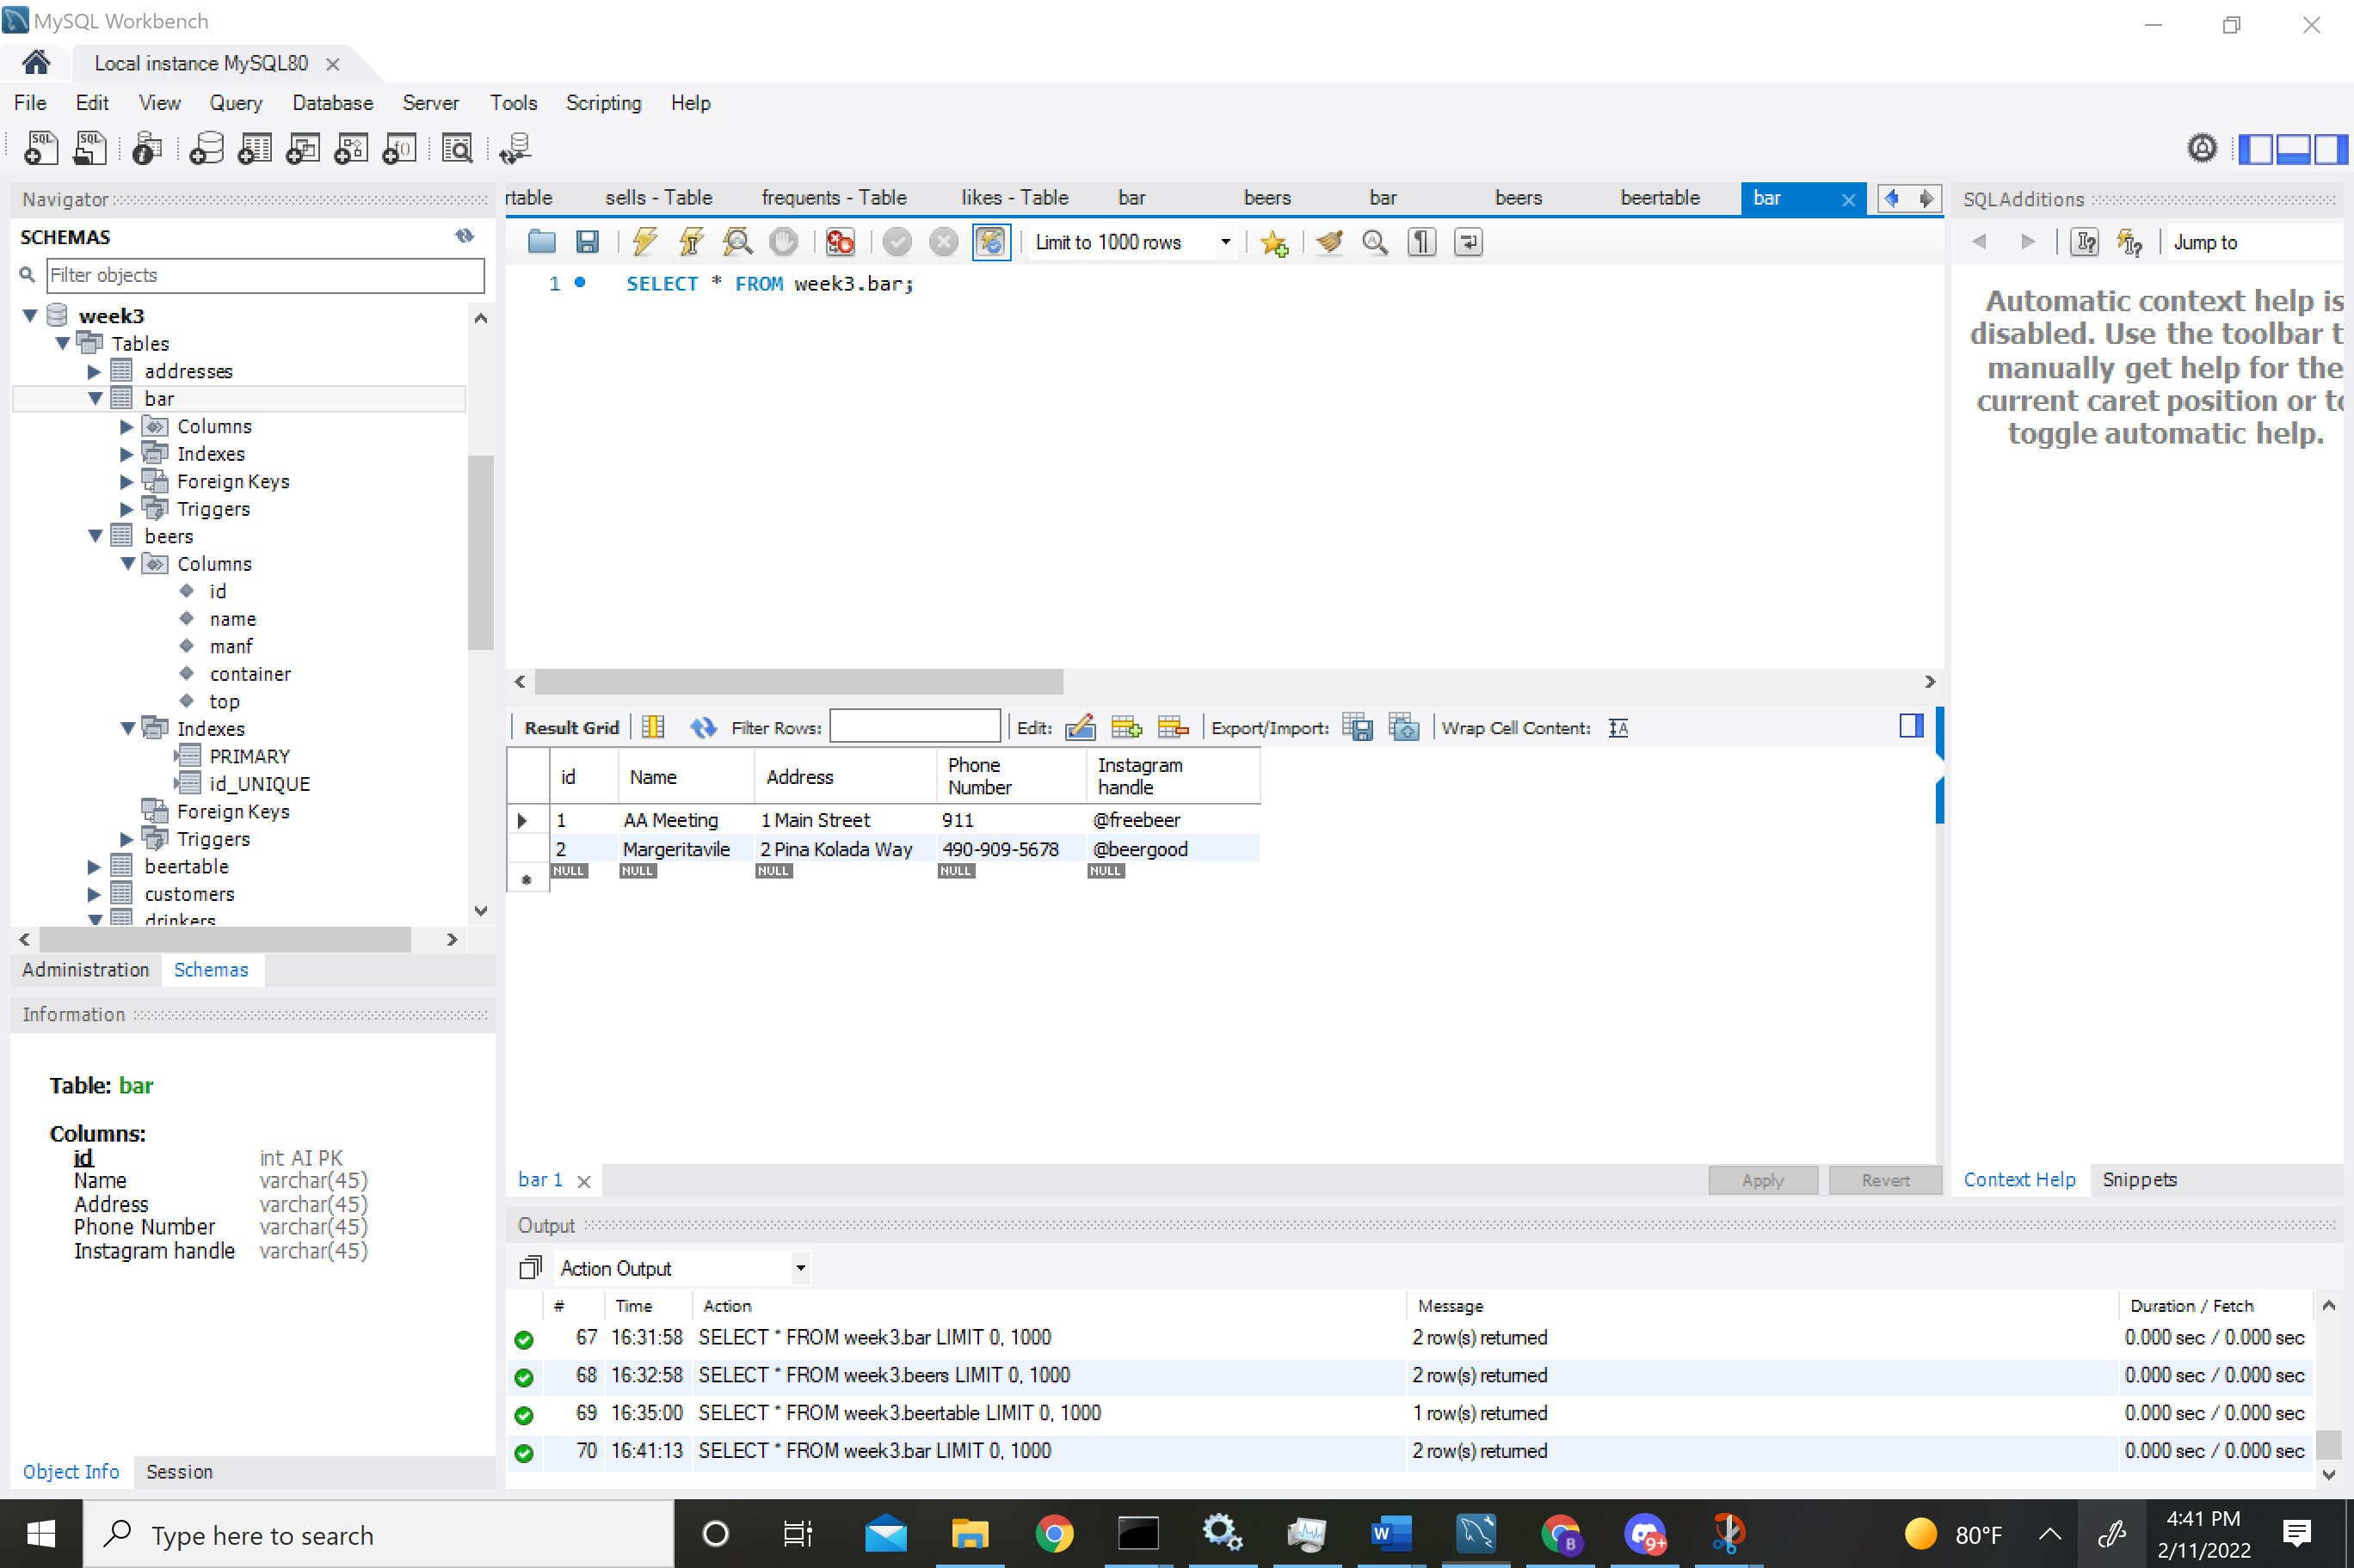

Likes Table

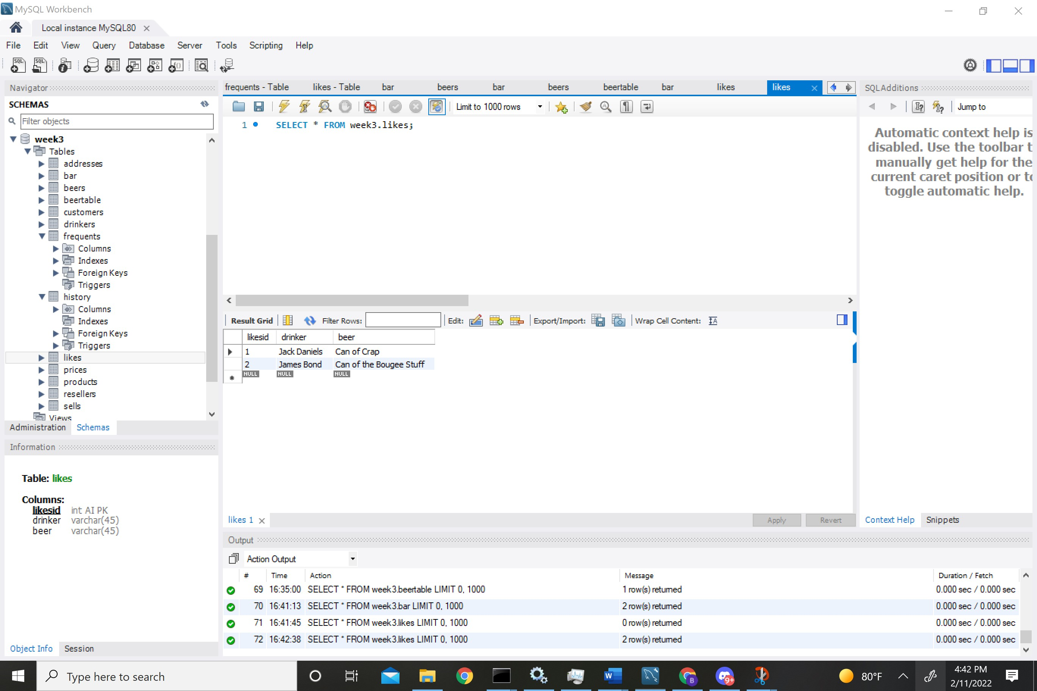

Frequents

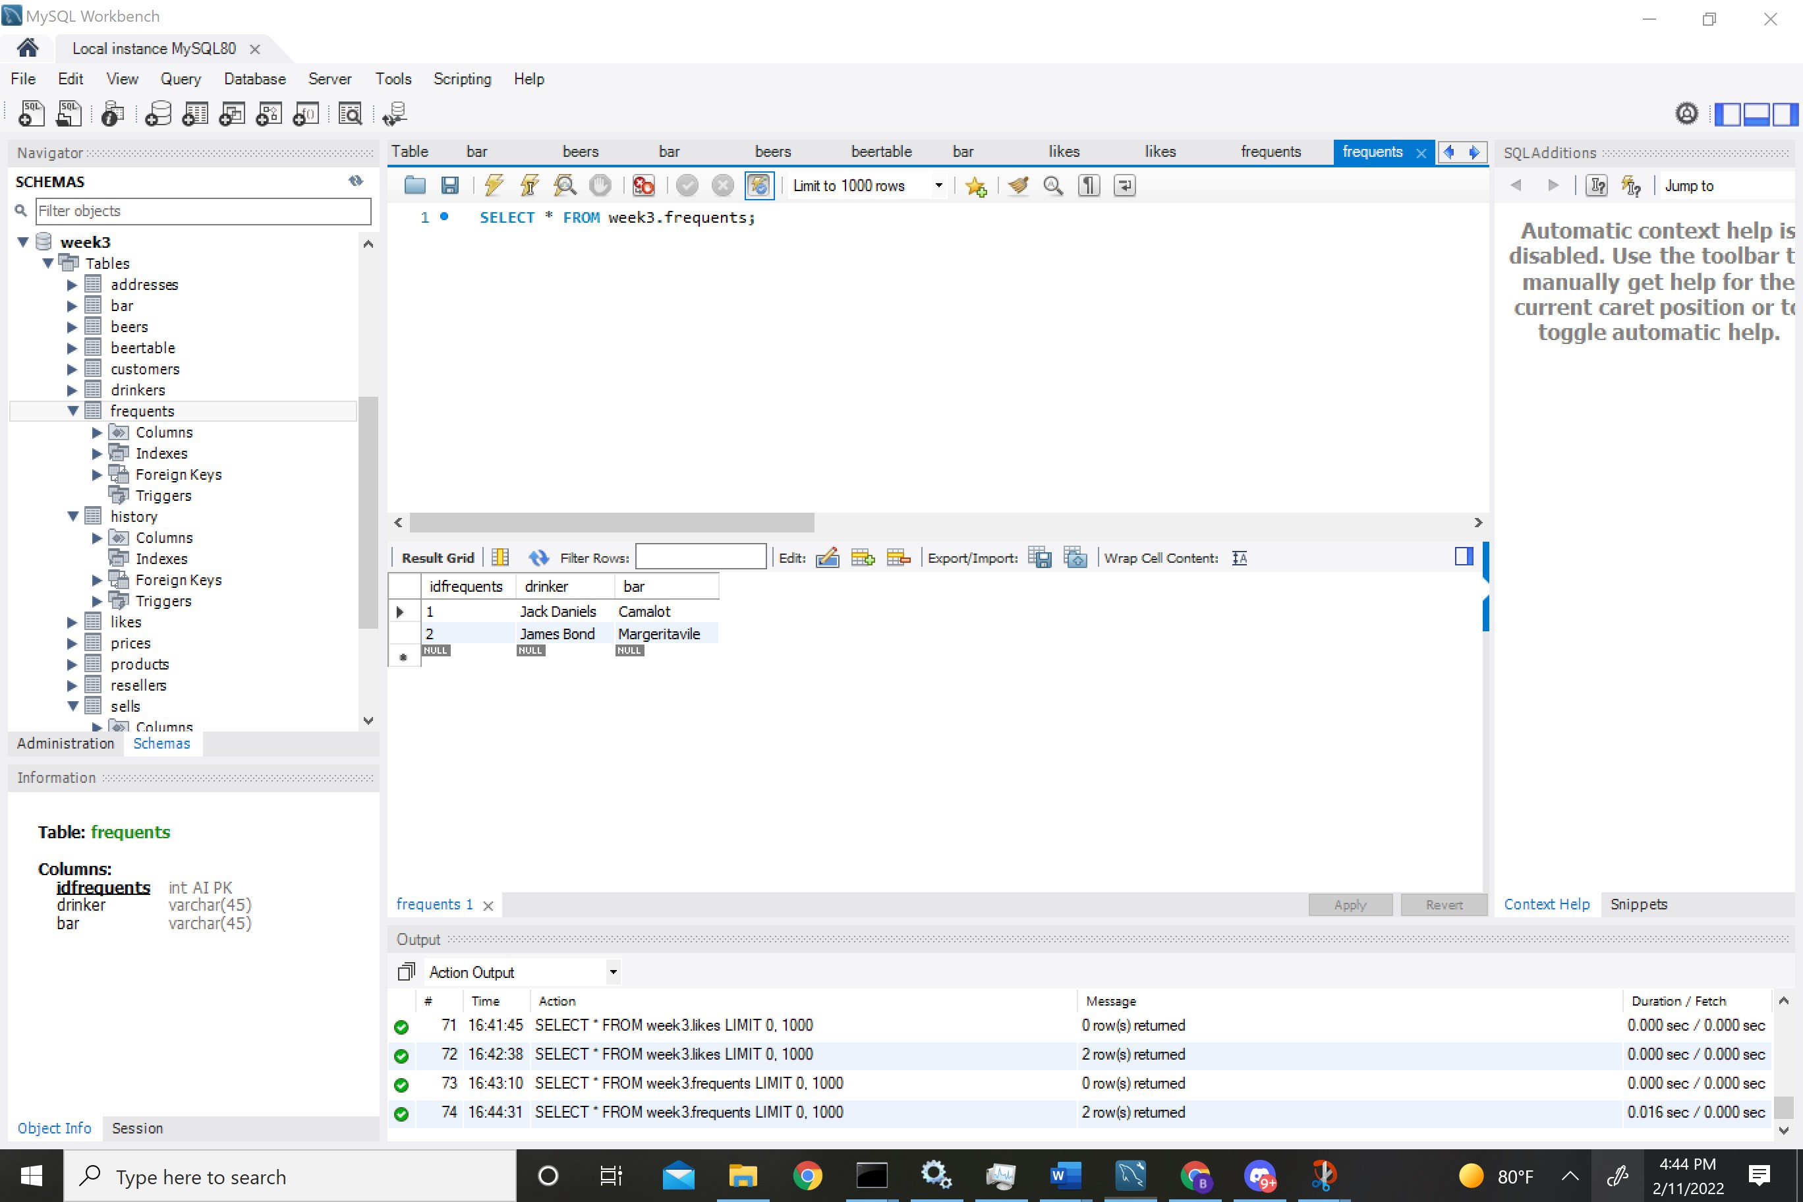

Sells

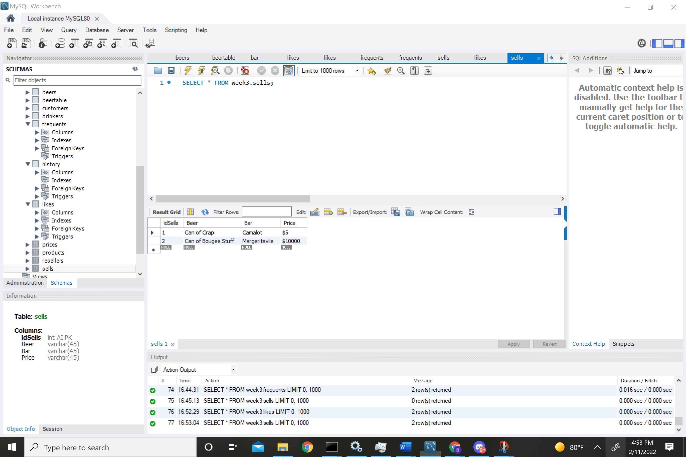

Join Query Sells and Likes-> Pairs Drinkers with the appropriate bar.

SELECT drinker, Beer_Being_Sold, beer_liked, bar FROM week3.sells, week3.likes where Beer_Being_Sold = beer_liked;

